aMBSE Stakeholder Analysis

A stakeholder analysis helps you identify which stakeholders are being impacted by your project, where each stands on receptiveness to the change, what capabilities are needed by varisou stakeholders, and which ones can impact the project success the most. Stakeholder assessment is a critical component of effective business change management because it increases the success of your stakeholder engagement and management. Stakeholders make projects successful, while end users make products successful. As such Stakeholder analysis at the beginning of a project can be just as important as end user analysis.

The primary output for stakeholder analysis is the stakeholder canvas, which summarizes the key stakeholder responsibilities, concerns, objectives, pains, and views of the system.

Read more in the SeBoK:
https://sebokwiki.org/wiki/Stakeholder_Needs_Definition

%#Stakeholder#% Canvas Diagram

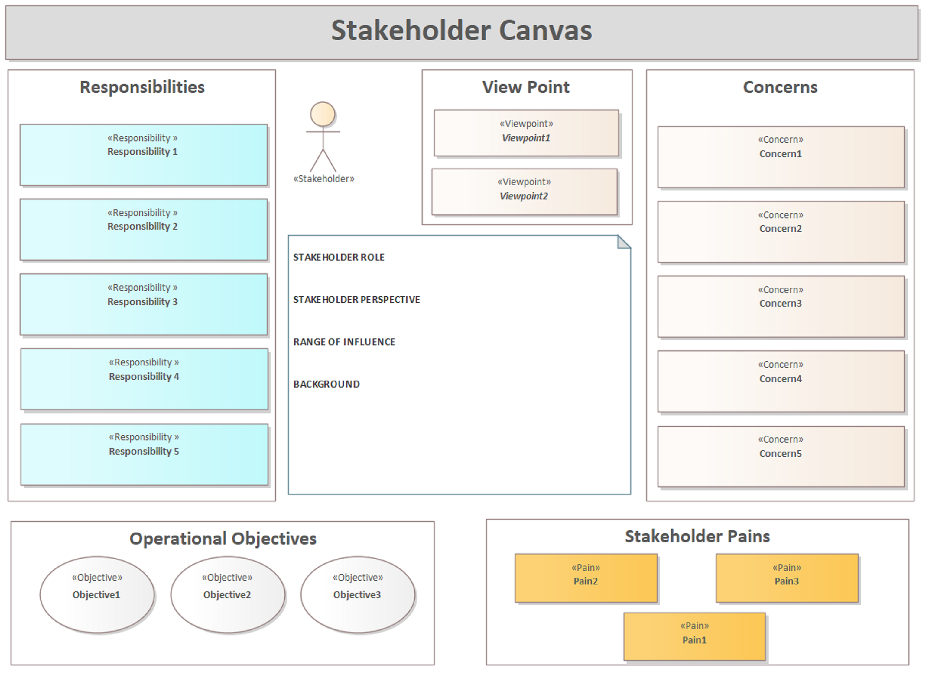

- %#Stakeholder#% Canvas

Concerns

Operational Objectives

Responsibilities

Stakeholder Canvas

Stakeholder Pains

View Point

Viewpoint1

Viewpoint2

Note

STAKEHOLDER ROLE

STAKEHOLDER PERSPECTIVE

RANGE OF INFLUENCE

BACKGROUND

Objective1

Objective2

Objective3

Stakeholder

STAKEHOLDER ROLE

STAKEHOLDER PERSPECTIVE

RANGE OF INFLUENCE

BACKGROUND

Pain1

PAIN POINT DESCRIPTION

CONTEXT

IMPACT

Pain2

PAIN POINT DESCRIPTION

CONTEXT

IMPACT

Pain3

PAIN POINT DESCRIPTION

CONTEXT

IMPACT

Responsibility 1

RESPONSIBILITY DESCRIPTION

INTERFACE

Responsibility 2

RESPONSIBILITY DESCRIPTION

INTERFACE

Responsibility 3

RESPONSIBILITY DESCRIPTION

INTERFACE

Responsibility 4

RESPONSIBILITY DESCRIPTION

INTERFACE

Responsibility 5

RESPONSIBILITY DESCRIPTION

INTERFACE

Concern1

CONCERN DESCRIPTION

SOURCE FOR CONCERN

REFERENCE DATA

Concern2

CONCERN DESCRIPTION

SOURCE FOR CONCERN

REFERENCE DATA

Concern3

CONCERN DESCRIPTION

SOURCE FOR CONCERN

REFERENCE DATA

Concern4

CONCERN DESCRIPTION

SOURCE FOR CONCERN

REFERENCE DATA

Concern5

CONCERN DESCRIPTION

SOURCE FOR CONCERN

REFERENCE DATA

Stakeholder Pattern Elements

This contains the standard definitions for elements used to define the stakeholders. Each element is defined and a template with a best practice for describing that element is provided.

Stakeholder Pattern Elements Diagram

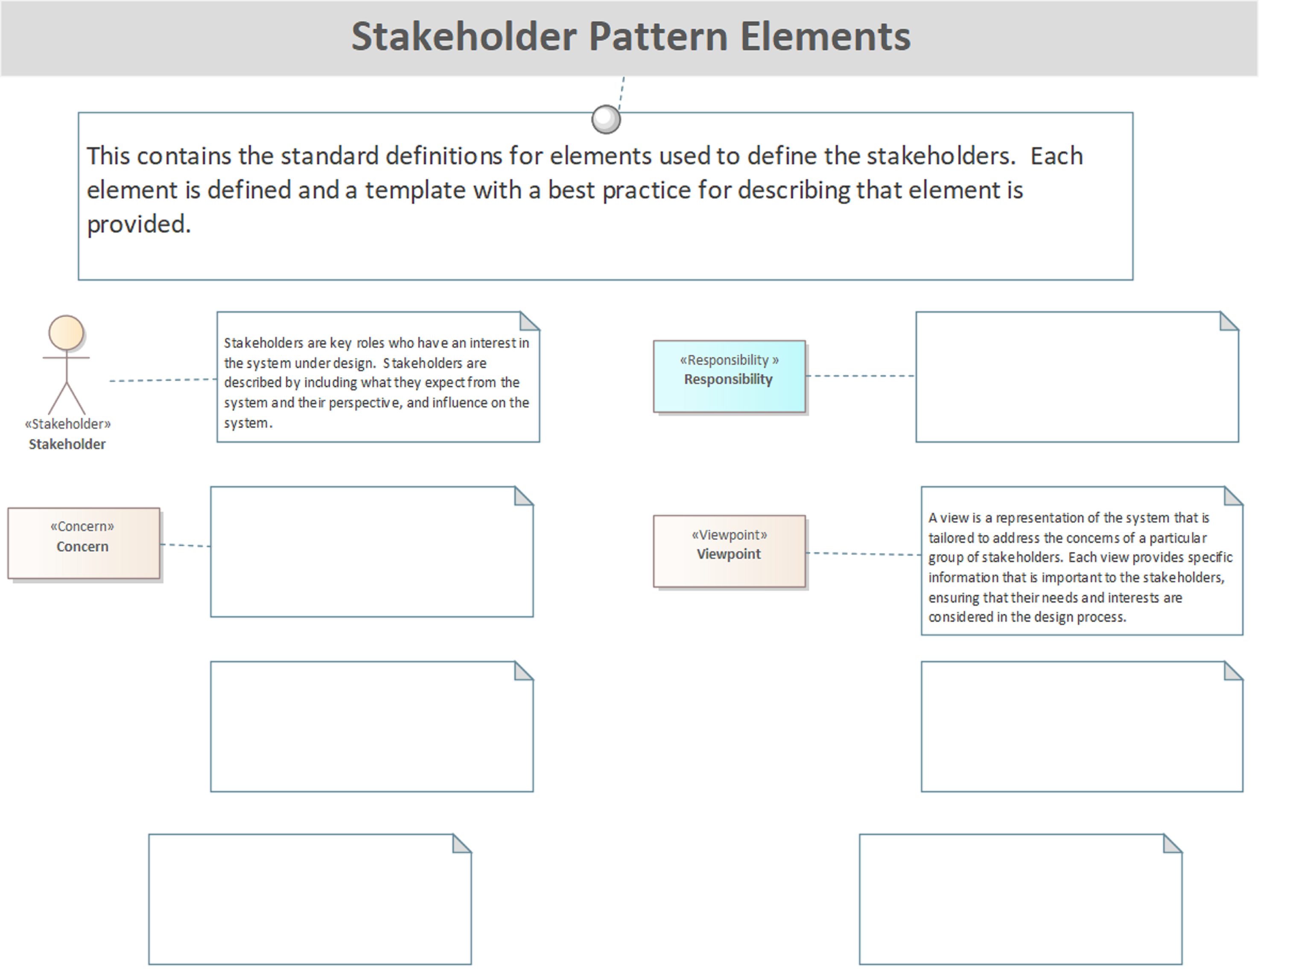

- Stakeholder Pattern Elements

Stakeholder Pattern Elements

This contains the standard definitions for elements used to define the stakeholders. Each element is defined and a template with a best practice for describing that element is provided.

Stakeholder

Stakeholders are key roles who have an interest in the system under design. Stakeholders are described by including what they expect from the system and their perspective, and influence on the system.

Concern

Responsibility

Viewpoint

A view is a representation of the system that is tailored to address the concerns of a particular group of stakeholders. Each view provides specific information that is important to the stakeholders, ensuring that their needs and interests are considered in the design process.

Stakeholder Elements

Stakeholders are key roles who have an interest in the system under design. Stakeholders are described by including what they expect from the system and their perspective, and influence on the system.

The following template shows the best practice used for documenting this element:

Stakeholder ## - Name

STAKEHOLDER ROLE
The role that the stakeholder plays in the ecosystem where the system of interest will be deployed.

STAKEHOLDER PERSPECTIVE
What is the stakeholder's perspective of the system of interest.

RANGE OF INFLUENCE
What is the range of influence the stakeholder has over the development process, deployment, maintenance, and service of the system.

BACKGROUND
Provide any background information on the stakeholder that helps to solidify their perspective to the development team.

Stakeholder Elements Diagram

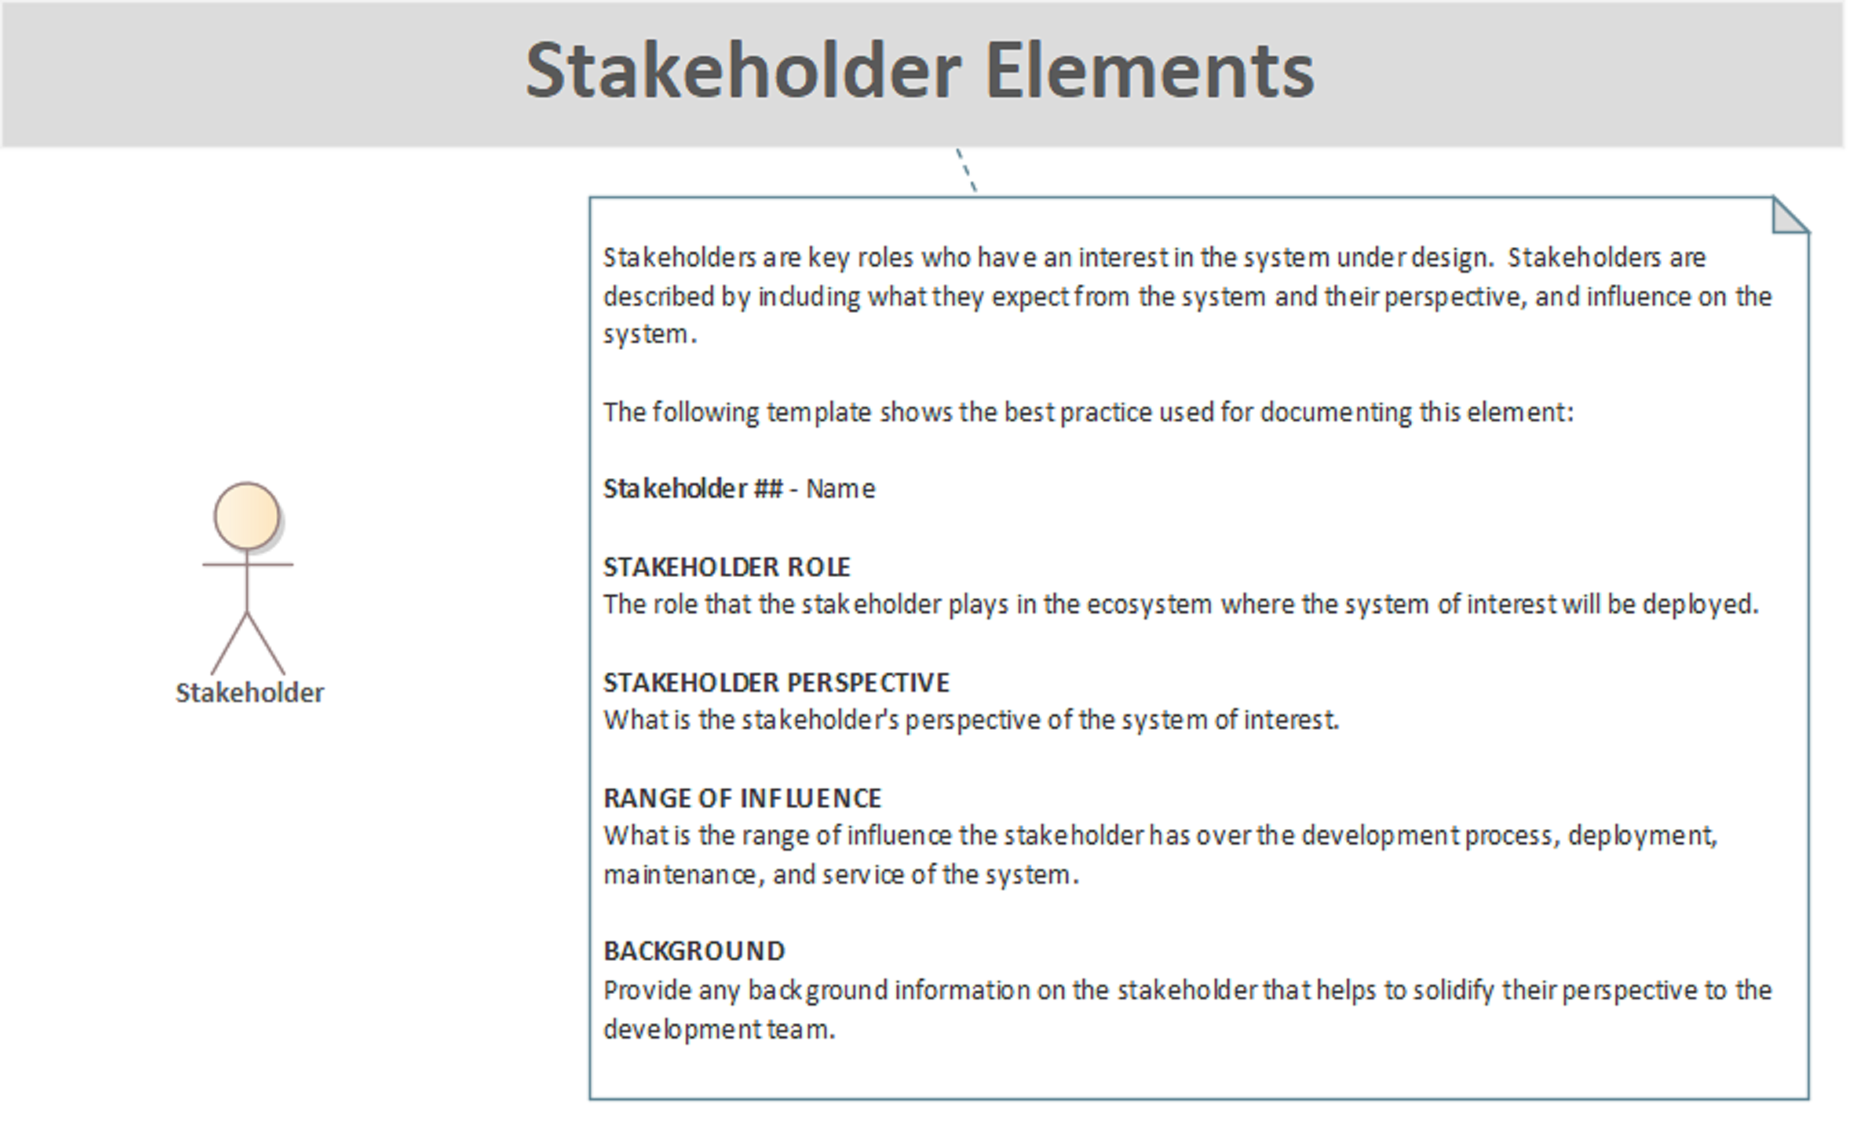

- Stakeholder Elements

Stakeholder Elements

Stakeholders are key roles who have an interest in the system under design. Stakeholders are described by including what they expect from the system and their perspective, and influence on the system.

The following template shows the best practice used for documenting this element:

Stakeholder ## - Name

STAKEHOLDER ROLE
The role that the stakeholder plays in the ecosystem where the system of interest will be deployed.

STAKEHOLDER PERSPECTIVE
What is the stakeholder's perspective of the system of interest.

RANGE OF INFLUENCE
What is the range of influence the stakeholder has over the development process, deployment, maintenance, and service of the system.

BACKGROUND
Provide any background information on the stakeholder that helps to solidify their perspective to the development team.

Stakeholder

Stakeholders are key roles who have an interest in the system under design. Stakeholders are described by including what they expect from the system and their perspective, and influence on the system.

Responsibility Elements

Responsibility are ****** , etc. Responsibility represent **** to the system *****

The following template shows the best practice used for documenting this element:

Responsibility ## - Name

DESCRIPTION
Responsibility are .

CONTEXT
Provide brief context that includes:

- .

Responsibility Elements Diagram

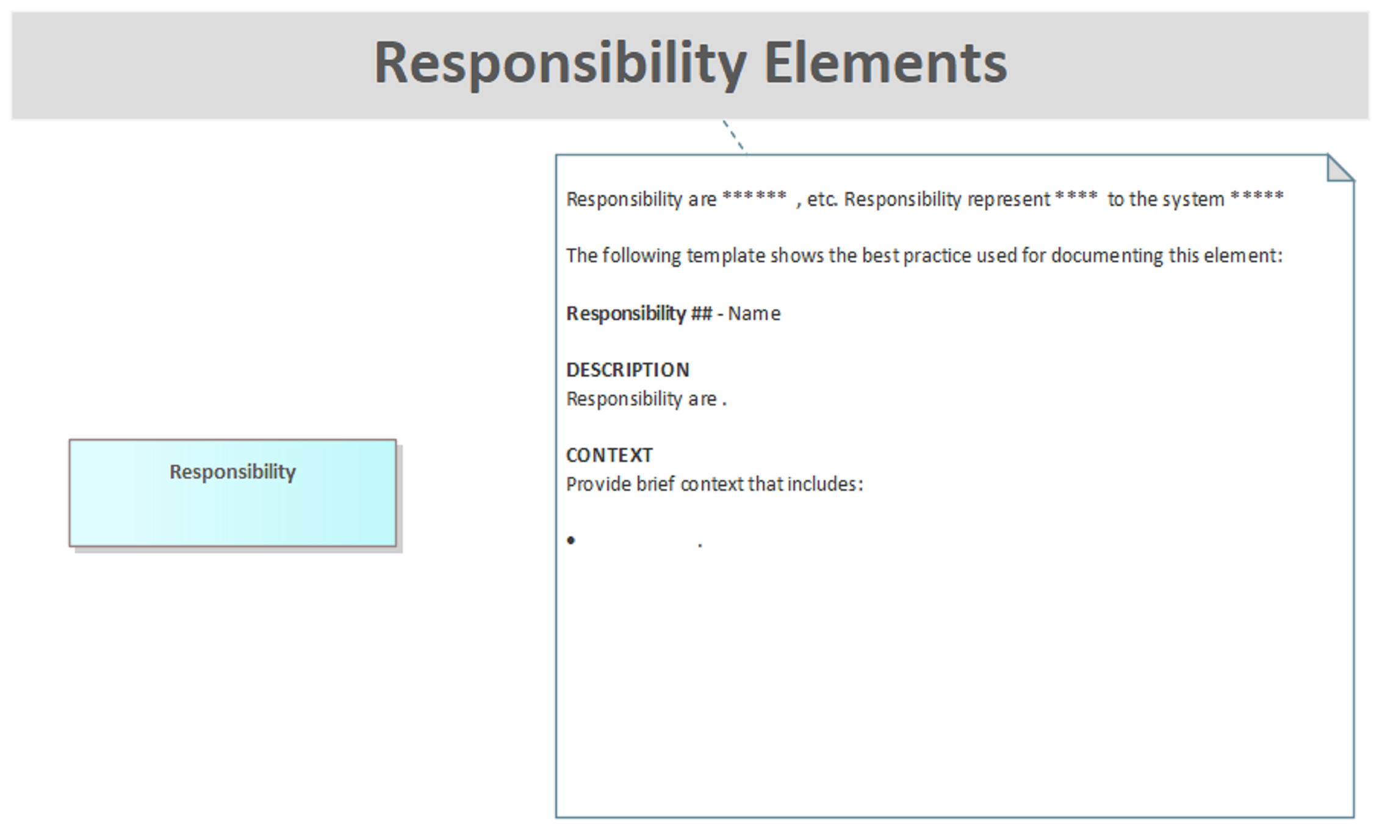

- Responsibility Elements

Responsibility Elements

Responsibility are ****** , etc. Responsibility represent **** to the system *****

The following template shows the best practice used for documenting this element:

Responsibility ## - Name

DESCRIPTION
Responsibility are .

CONTEXT
Provide brief context that includes:

.

Responsibility

Concern Elements

Concern are ****** , etc. %Concern represent **** to the system *****

The following template shows the best practice used for documenting this element:

Concern ## - Name

DESCRIPTION
Concern are.

CONTEXT
Provide brief context that includes:

- .

Concern Elements Diagram

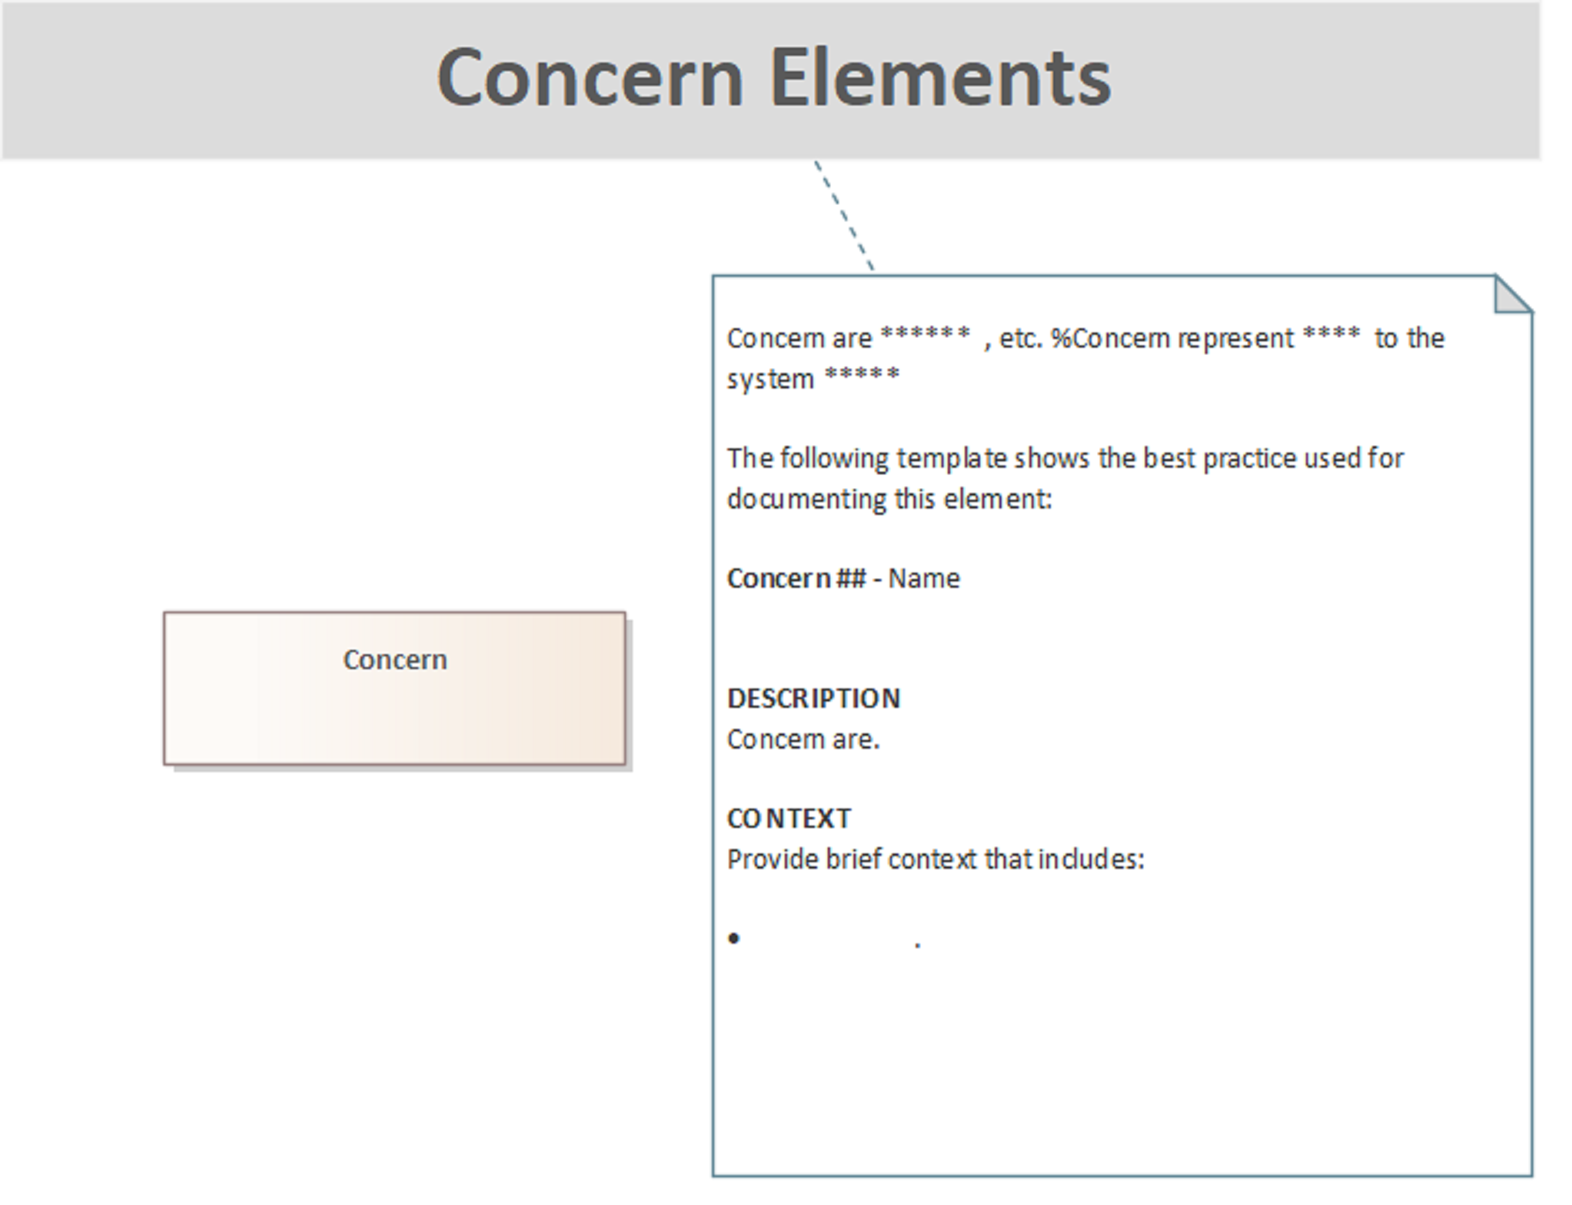

- Concern Elements

Concern Elements

Concern are ****** , etc. %Concern represent **** to the system *****

The following template shows the best practice used for documenting this element:

Concern ## - Name

DESCRIPTION
Concern are.

CONTEXT
Provide brief context that includes:

.

Concern

Viewpoint Elements

Viewpoints are the representation of the

The following template shows the best practice used for documenting this element:

Viewpoint ## - Name

DESCRIPTION
A brief description of the view, typically related to the perspective it offers (e.g., Logical View, Physical View, Deployment View, etc.), explaining what aspects of the system it represents and why it is important.

CONCERNS
The specific concerns or questions that the view answers. This might include performance, security, scalability, maintainability, etc.

MODEL(S)
The model or models used to represent this view (e.g., UML diagrams, data flow diagrams, etc.).

ELEMENTS
The key architectural elements included in the view. This might include components, connectors, modules, or any other significant architectural artifacts.

RATIONALE
The reasoning behind the inclusion of specific elements or models in the view, explaining how they address stakeholder concerns.

Viewpoint Elements Diagram

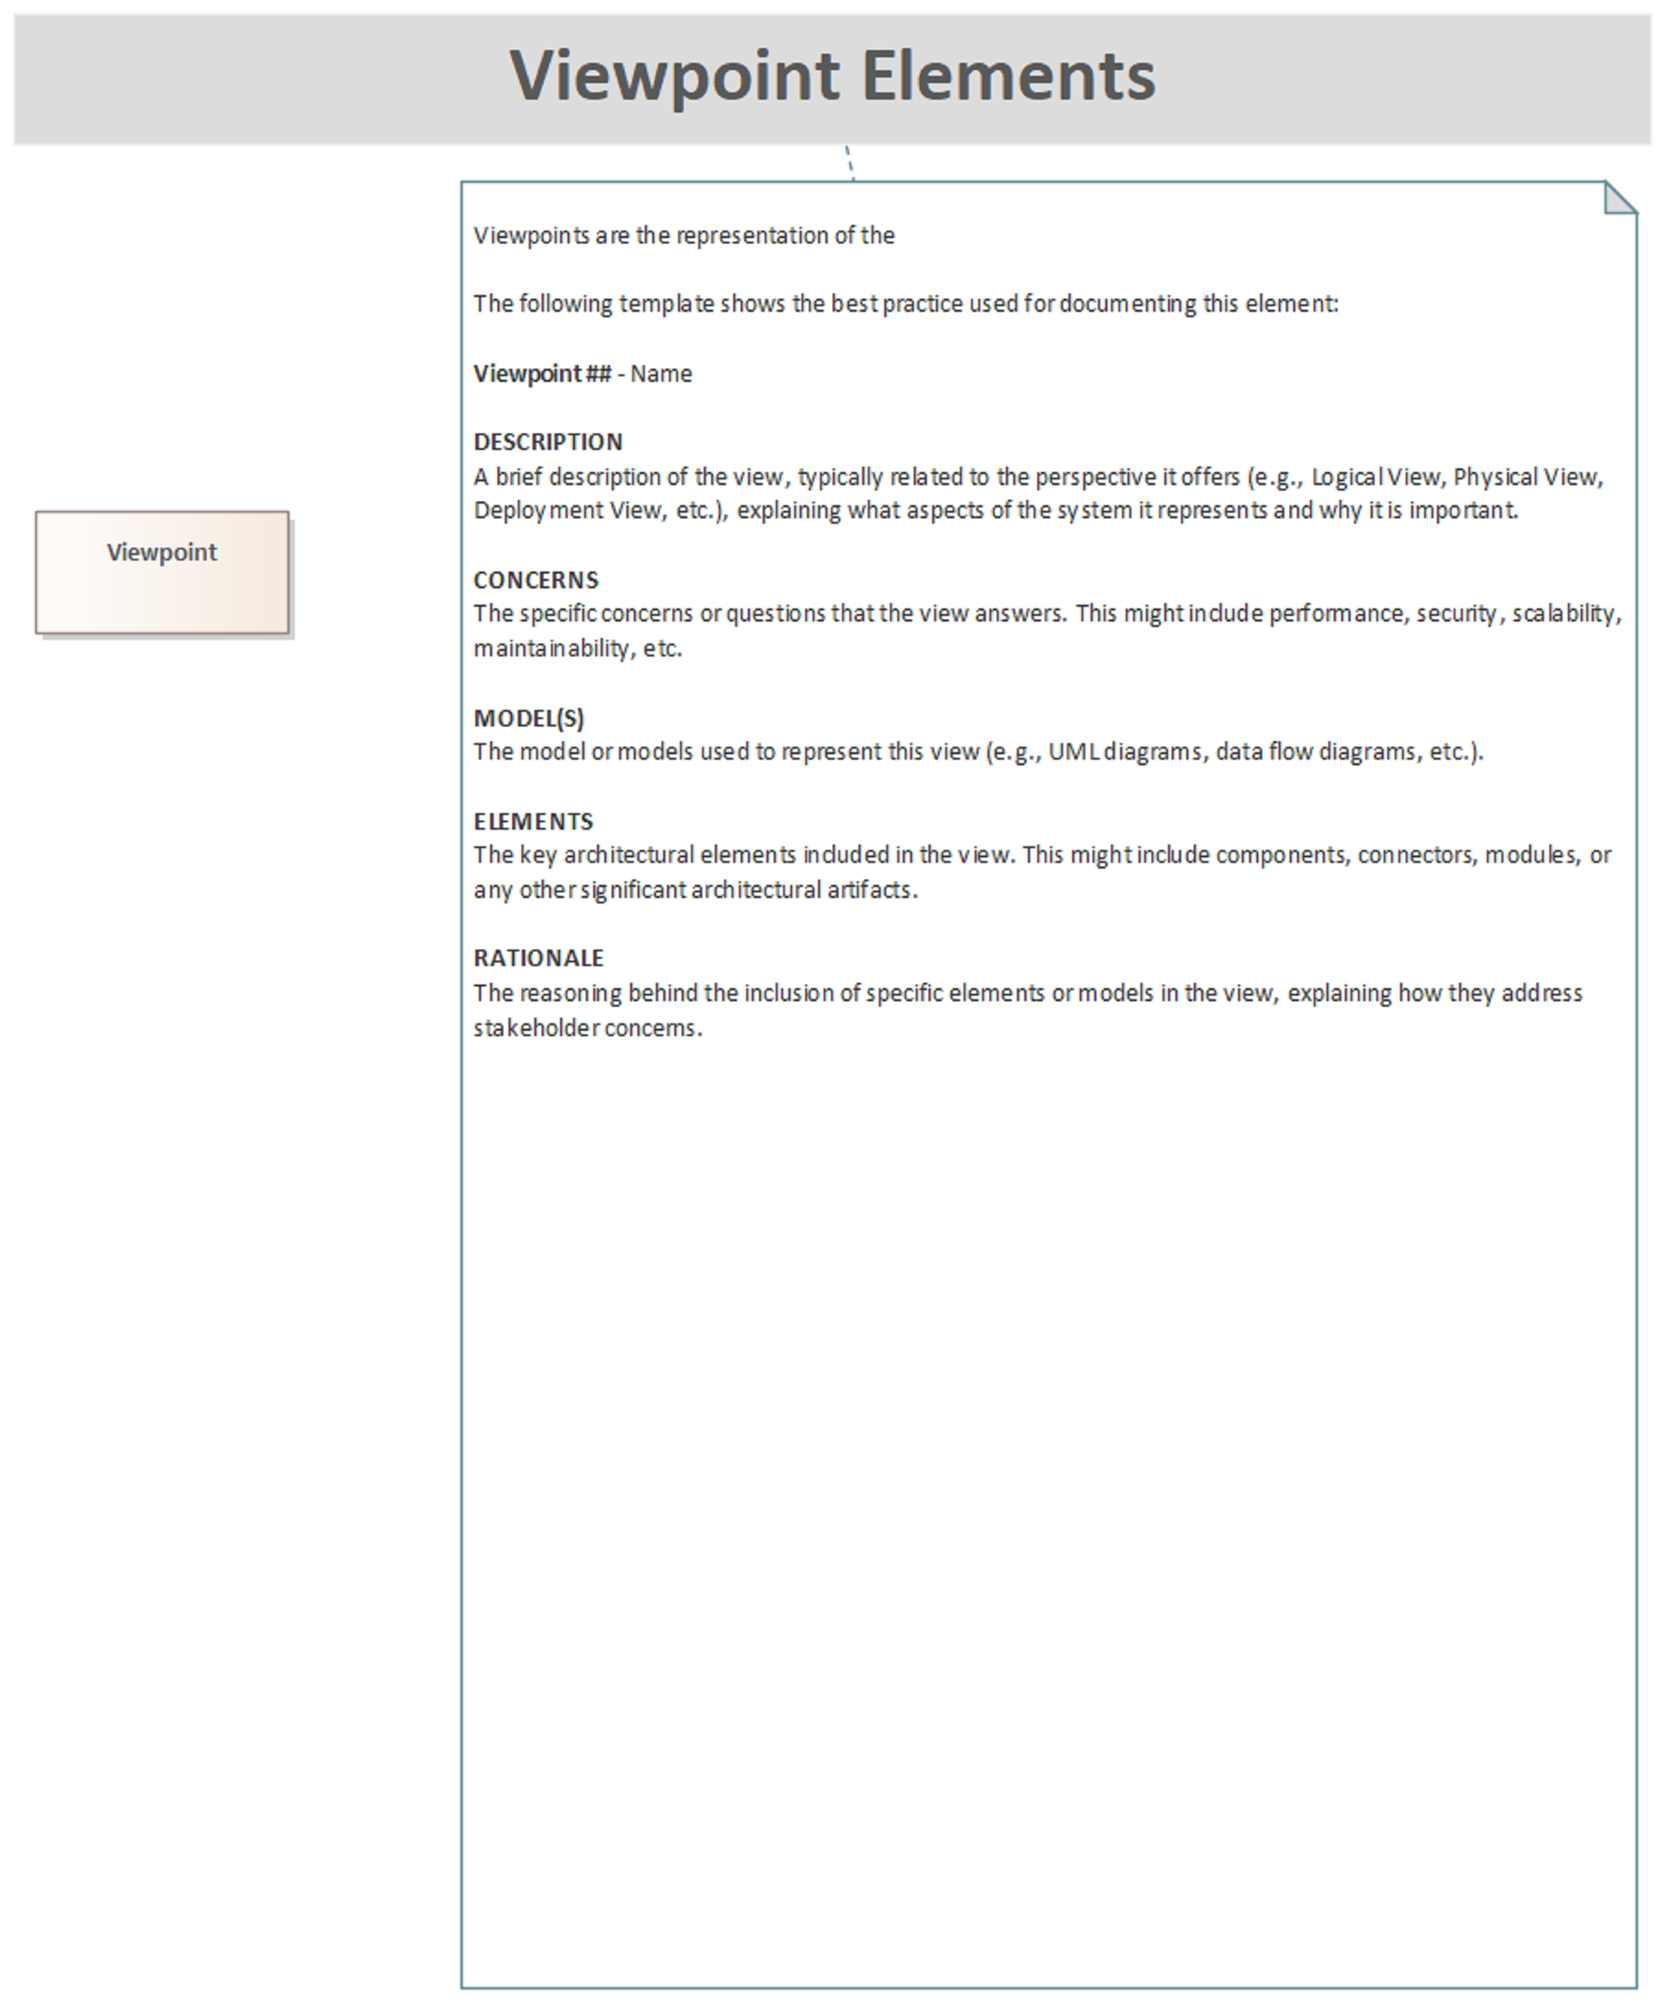

- Viewpoint Elements

Viewpoint Elements

Viewpoints are the representation of the

The following template shows the best practice used for documenting this element:

Viewpoint ## - Name

DESCRIPTION
A brief description of the view, typically related to the perspective it offers (e.g., Logical View, Physical View, Deployment View, etc.), explaining what aspects of the system it represents and why it is important.

CONCERNS
The specific concerns or questions that the view answers. This might include performance, security, scalability, maintainability, etc.

MODEL(S)
The model or models used to represent this view (e.g., UML diagrams, data flow diagrams, etc.).

ELEMENTS
The key architectural elements included in the view. This might include components, connectors, modules, or any other significant architectural artifacts.

RATIONALE
The reasoning behind the inclusion of specific elements or models in the view, explaining how they address stakeholder concerns.

Viewpoint

A view is a representation of the system that is tailored to address the concerns of a particular group of stakeholders. Each view provides specific information that is important to the stakeholders, ensuring that their needs and interests are considered in the design process.

aMBSE Stakeholder Analysis Domain

Stakeholder Analysis Domain Diagram

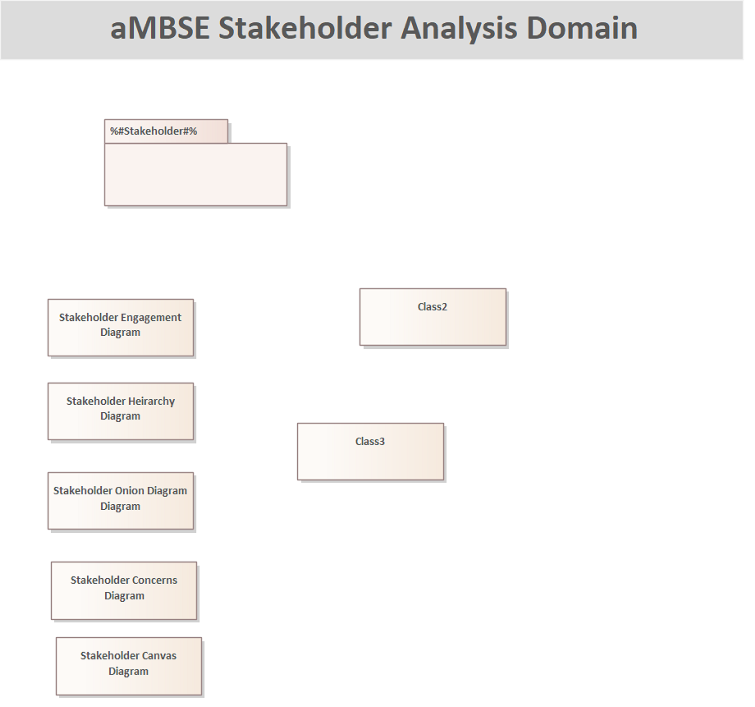

- Stakeholder Analysis Domain

aMBSE Stakeholder Analysis Domain

%#Stakeholder#%

Class2

CLASS DESCRIPTION

Class3

CLASS DESCRIPTION

Main Nav page

Stakeholder Canvas Diagram

CLASS DESCRIPTION

Stakeholder Concerns Diagram

Stakeholder Engagement Diagram

Stakeholder Heirarchy Diagram

Stakeholder Onion Diagram Diagram

